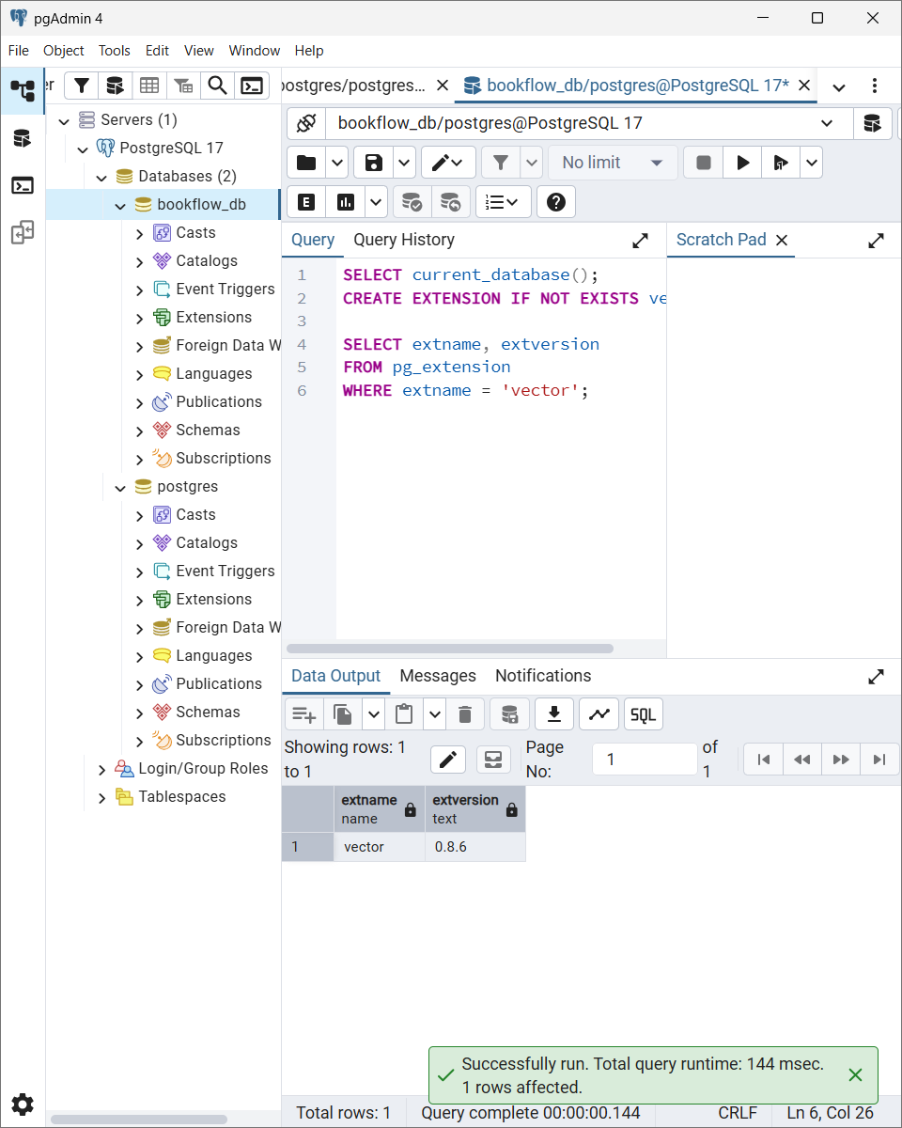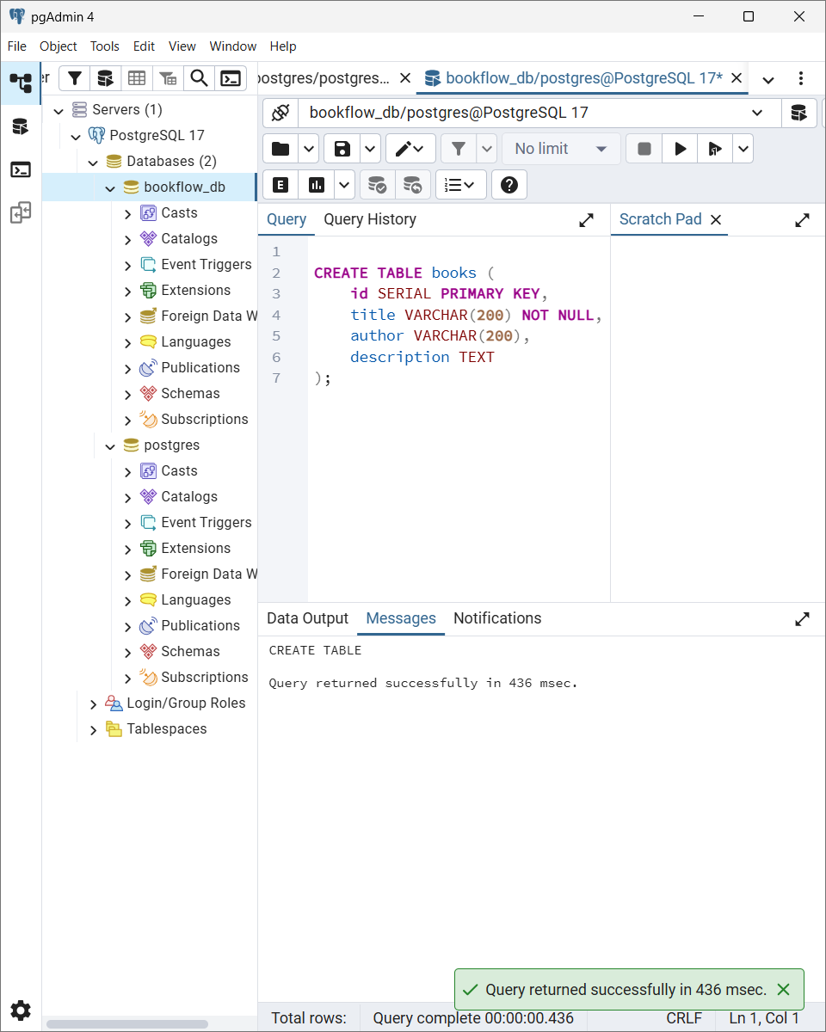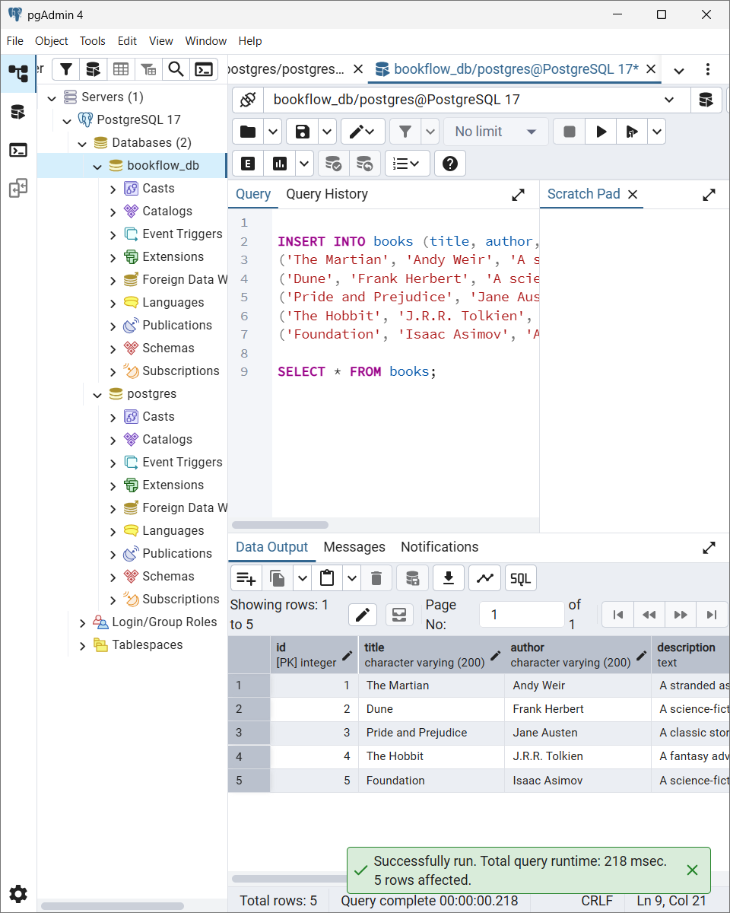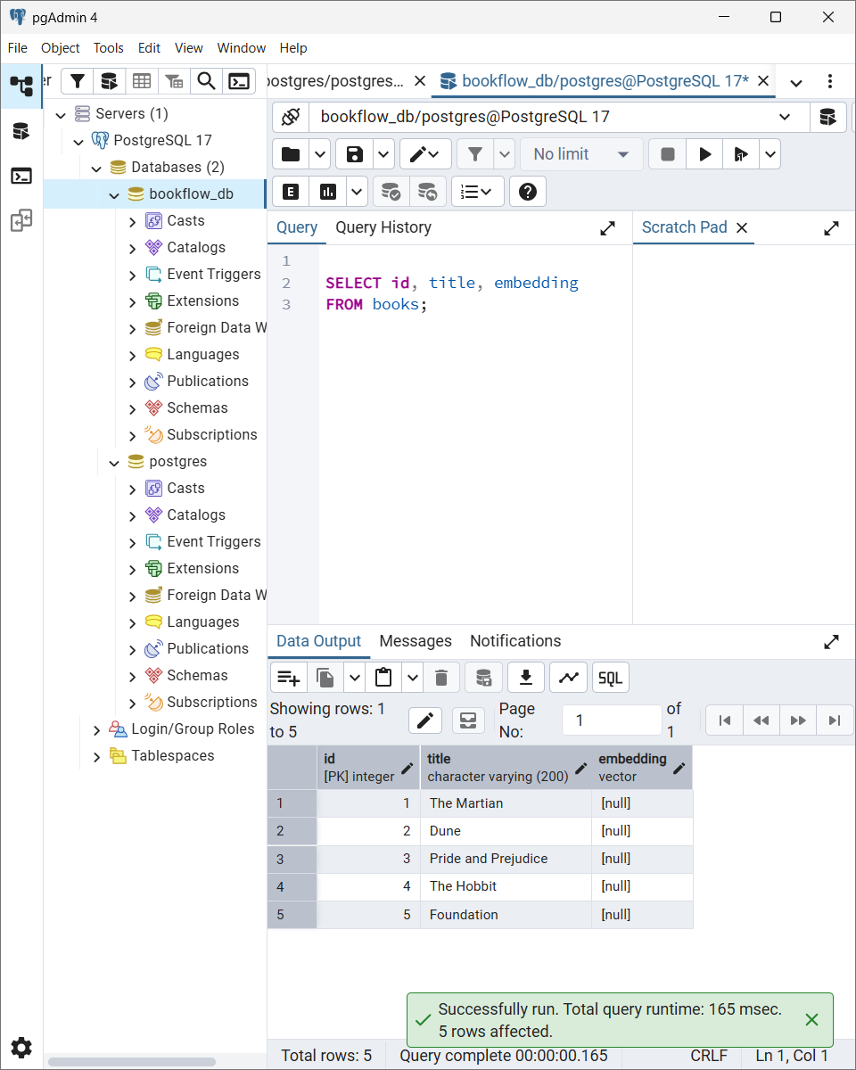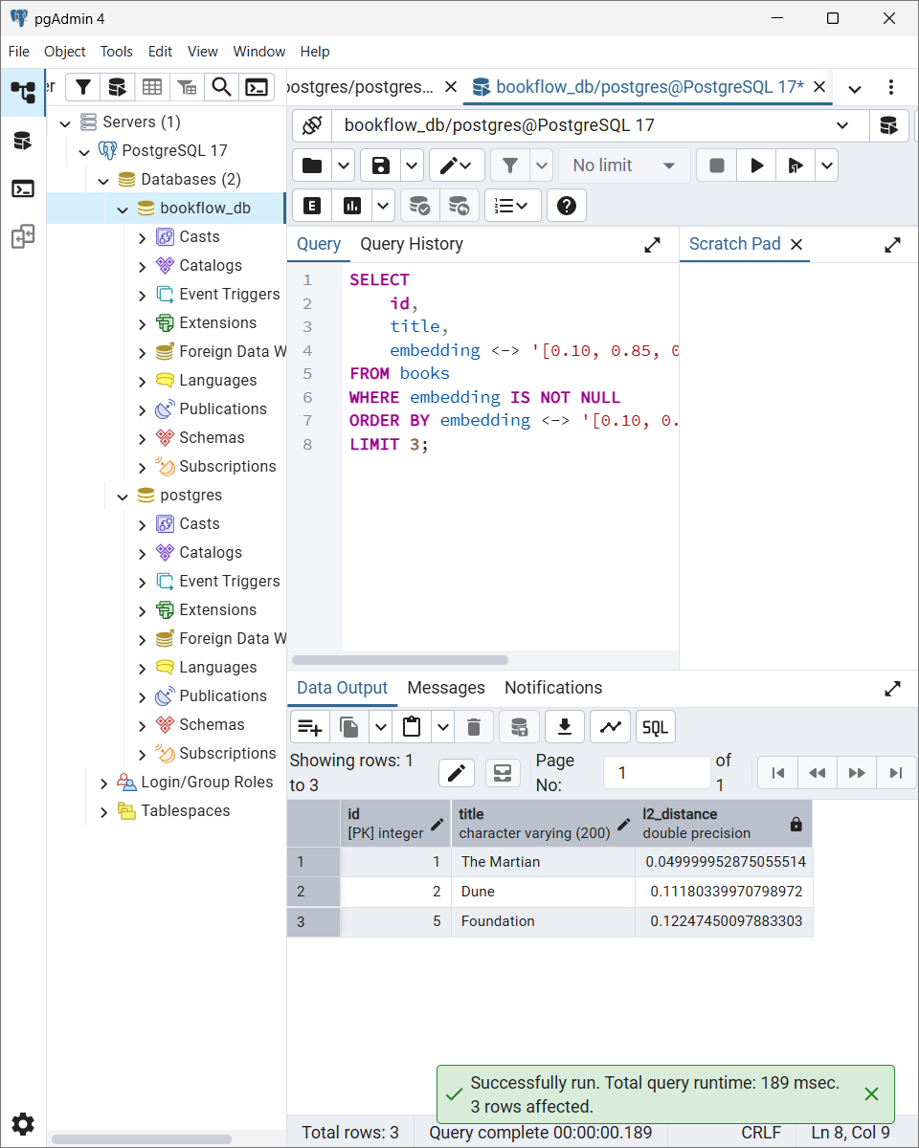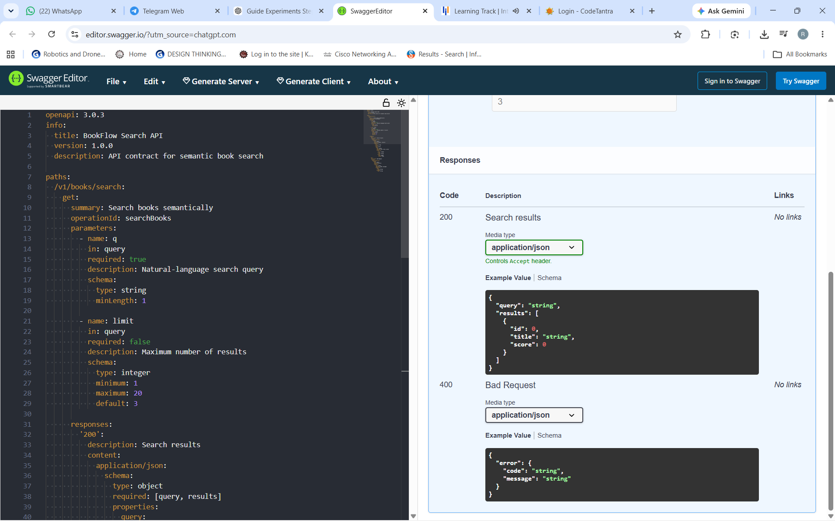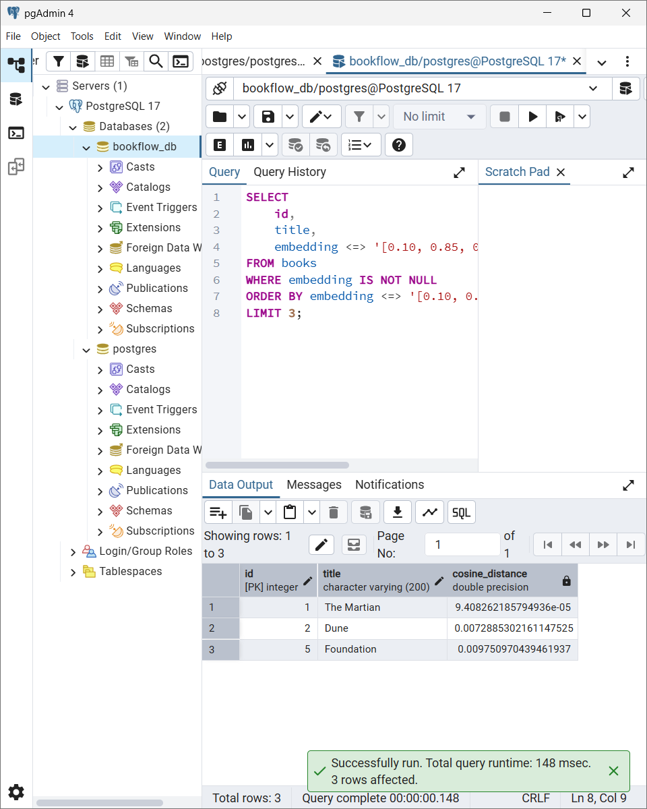

Conclusion:
The Intelligent Catalog and API Blueprint was successfully implemented using PostgreSQL and pgvector. A bookflow_db database and books table were created with sample book data and 3-dimensional mock embeddings. L2 and cosine vector similarity searches were performed to rank books based on their similarity to a query vector. An OpenAPI contract for the semantic book search API was also designed and successfully rendered using Swagger Editor.

